GRANARD MUNICIPAL DISTRICT

Corporate Affairs,
Aras an Chontae,
LONGFOIRT.

24th January 2018.

To: Each Member of Granard Municipal District.

Dear Member,

You are requested to attend Meeting of Granard Municipal District to be held in
Granard Community Library on Tuesday, 30th January 2018 at 3.30 p.m. to transact business, as set out on the Agenda hereunder.

Yours sincerely,
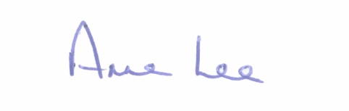

_______________
Anne Lee,
Meetings Administrator.

AGENDA

Prayer before meeting.

1. Confirmation of Minutes of Granard Municipal District Meeting held on the 28th November 2017 - copy enclosed.

2. Matters arising from Minutes.

3. Area Engineer’s Progress Report.

4. Consideration of the taking in charge of “Clos Naomh Padraig”, Ballinamuck, Co. Longford - details enclosed.

5. Consideration and adoption of Draft Municipal District Report for inclusion in Longford County Council 2017 Annual Report -enclosed.

6. Notices of Motions submitted by Councillor Michael Carrigy.

“I call on Longford County Council to allocate funding to carry out repairs at the playground/basketball facilities at Higginstown, Granard.”

“I request an update on the agreement to erect an art piece to recognise the achievements of Eddie Macken and the late Brendan O'Reilly in Granard.”

7. Correspondence dated 8th January 2018 received from the Office of Public Works regarding parking at the rear of the Garda Station in Granard – enclosed.

8. A.O.B.

